MEMORANDUM

TO: Cape Elizabeth Town Council
FROM: Planning Board
DATE: March 19, 2014
SUBJECT: Normal High Water Line Zoning Amendments

Introduction

At the March 11, 2013 meeting, the Town Council referred to the Planning Board a request to review the normal high water line in coastal waters definition. The Planning Board has held 8 workshops, and 6 regular meetings, including 3 public hearings, in their review of possible amendments to the normal high water line definition. The Planning Board has developed a replacement definition that is tied to the Highest Astronomical Tide plus 3 vertical feet and a clarifying map interpretation amendment. The proposed amendments are attached.

Referral to the Planning Board

The current definition follows:

Normal High Water Line of Coastal Waters: That line on the shore of tidal waters which is the apparent extreme limit of the effect of the tides, i.e. the top of the bank, cliff or beach above high tide.

The Town Council referred the normal high water line definition for review at the request of Code Enforcement Officer Ben McDougal, whose concerns follow:

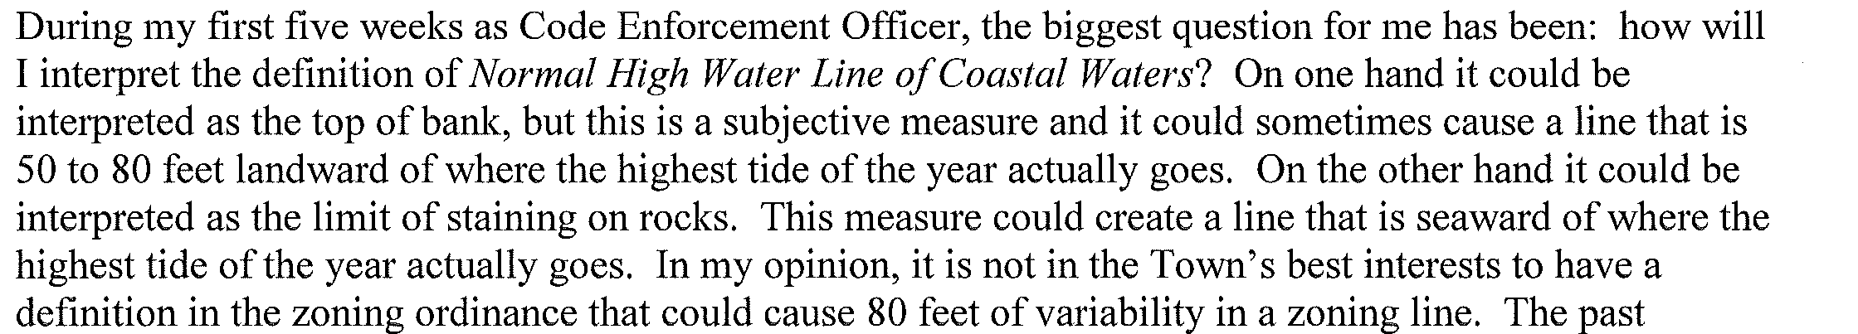

The disadvantages of having a variable definition are also demonstrated by the pending three lawsuits that include challenges to the former Code Enforcement Officer’s determination of the normal high water line. Mr. McDougal is recommending that “the Town have a definition that enables land use professionals to determine the line based on objective and scientifically sound criteria.”

Top of Bank Definition

Early in the process, the Planning Board considered keeping the current definition, commonly referred to as the “Top of Bank.” The challenge with using the current definition is that almost all sites have a varying slope from the water’s edge rather than a clear break in the slope. In this situation, the Code Enforcement Officer must determine the normal high water line. The result has been that code enforcement officers mostly have been using the Highest Annual Tide as the normal high water line. This is the standard state DEP Shoreland Zoning definition.

Staff and Peter Slovinsky, Senior Marine Geologist with the Maine Geological Survey, have looked for other examples using a “top of bank” reference. There are no known examples in the state of Maine. Slopes have been factored into definitions used on the west coast. Those definitions have been geared to establishing setbacks due to unstable soils, and do not create a clear definition of top of bank when there is no clearly eroding slope.

The State Definition

The State of Maine requires municipalities to adopt Shoreland Zoning that complies with or exceeds minimum state standards. All shoreland zoning regulations must be submitted to the Department of Environmental Protection (DEP) for certification. The Town of Cape Elizabeth updated its Shoreland Zoning regulations in 2009 following state changes to Shoreland Zoning. The town’s update was submitted to DEP and found in compliance with state minimums. At that time, the town elected to retain the “top of bank” definition, which the DEP accepted because it was considered to be more restrictive than the state definition.

Mr. McDougal suggested that the Town “consider using the Maine Department of Environmental Protection [DEP] definition for coastal wetland. It is a clear definition with objective criteria for determining an accurate and consistent zoning boundary.” The state definition relies on Highest Annual Tide data to set the normal high water line in coastal areas.

The Planning Board reviewed the state definition and agreed with the benefits of using a definition for which the state could provide technical assistance. The state definition also met the criteria of consistent applicability by professionals and scientifically based, because it relied on Highest Annual Tide data.

At the Planning Board public hearing held in July 2013, however, public comment criticized this approach as weakening the town’s current, environmentally strict definition that uses the top of the bank. The Planning Board ‘s intent was to create a consistent and scientifically based definition, not to reverse the town’s longstanding commitment to strict environmental protection. As a result, the Planning Board tabled the amendment for further refinement.

Science

In his recommendation, Mr. McDougal concluded, “If the Town chooses to keep top of the bank in the definition, then the phrase should be further explained. The intent of this request is not to change Town policy, but rather to clarify it.”

In an effort to research alternatives, the Planning Board held a special workshop on October 29, 2013 where Peter Slovinsky, Senior Marine Geologist with the Maine Geological Survey, gave a presentation on Sea Level Rise. At the workshop, the Planning Board learned that the Maine Geological Survey is recommending to the DEP that the highest annual tide standard (HAT) be replaced with the “Highest Astronomical Tide” standard.

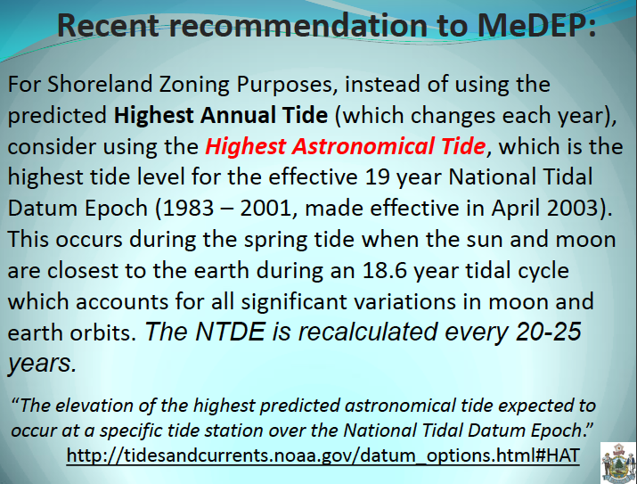

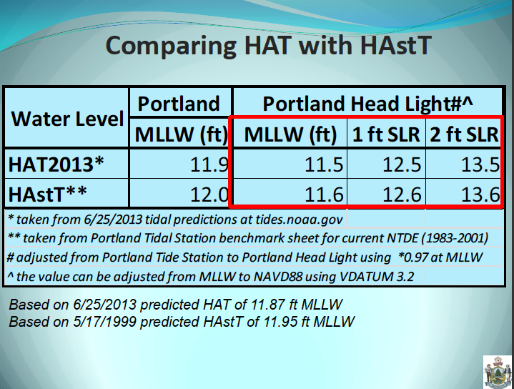

The Highest Astronomical Tide is slightly higher in elevation than the Highest Annual Tide. Its real benefit, however, is that it is a more stable number. The Highest Annual Tide is recalculated every year. Anyone building a conforming structure at the minimum setback could be made nonconforming the next year with the fluctuations of the annual high tide line. The Highest Astronomical Tide is based on a 19 year period and calculated by the National Oceanic and Atmospheric Administration using tidal data, in our case, collected in Portland Harbor. Tying the normal high water line to the Highest Astronomical Tide meets the consistent applicability and scientifically based criteria.

Preserve Strict Environmental Protection

Mr. Slovinsky’s presentation included comprehensive information on the trend of sea level rise globally and locally. The Planning Board noted that the “top of bank” definition and the Mack v. Town of Cape Elizabeth (1983) decision include the concept of establishing a line that reflects the extreme limit of the effect of the tides during a storm event. Mr. Slovinsky provided the following information regarding the increase in water levels during storm events.

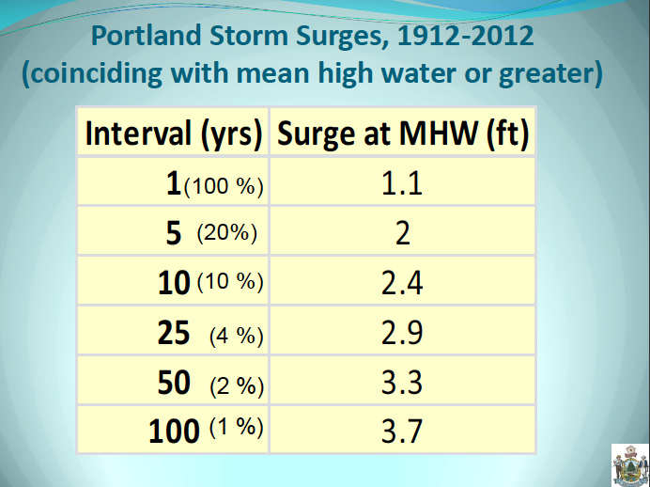

In order to address concerns that the town not reduce current environmental protection standards, while still establishing a standard that is consistent and based on science, the Planning Board proposed a definition that is based on the Highest Astronomical Tide, plus an additional 3 of vertical feet of elevation. The 3’ level was chosen as providing substantial protection from most storms. It also addresses concerns with the “apparent extreme limit of the effect of the tides” during a storm event by adding 3’ to the still water elevation of the Highest Astronomical Tide.

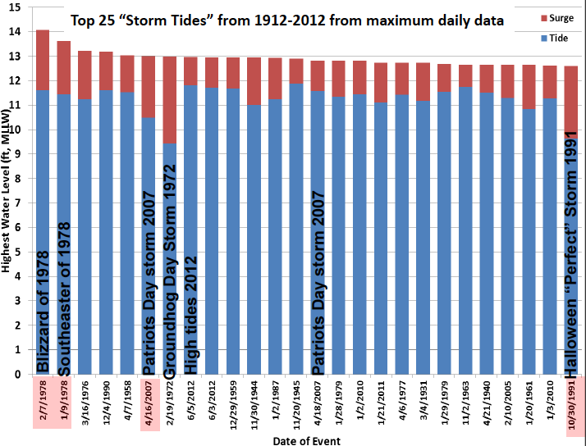

The chart above, provided by Mr. Slovinsky, shows the major storm tides in the last century. Some of the biggest storm surges have fortunately occurred near low rather than high tide. Using Highest Astronomical Tide of 11.6 MLLW plus 3’, the normal high water line would be at elevation 14.6 MLLW, which protects most properties for most storms even when a storm coincides with high tide.

Planning Board Chair Victoria Volent noted as follows:

The benchmarks for minor, moderate, and severe coastal flooding in Portland Harbor are 12.0 feet, 12.5 feet, and 13.0 feet respectively. The categories were established based on combined storm impact and the height of the peak storm tide. Severe coastal flooding events are rare and limited to the top 15 storm tides ever recorded in Portland (1914-2007). Along with the effects of extreme tides are large battering waves, which can cause significant damage. In recognition of water level fluctuations that include astronomical tides, storm surges, and long-term sea level rise or fall, the Planning Board is considering the adoption of the Highest Astronomical Tide plus three feet as the Normal High Water Line.

The Highest Astronomical Tide (HAstT) at Portland Head Light is 11.6’ (MLLW); plus three feet would be 14.6’ (MLLW). Given the 100 year storm tide level reaches 14.1’ and severe coastal flooding is at 13.0’ (in Portland Harbor), HAsT plus three feet will protect against coastal hazards as well as establish a setback that includes the splash over effect of large battering waves that cause significant damage.

The use of the Highest Astronomical Tide (HAsT) plus 3’ for delineating the normal high water line for shoreland zoning purposes is a forward looking proposal that addresses not only existing conditions, but potential future changes in coastal floodplains and wetlands. The use of the HAsT plus 3’: 1) helps account for the potential impacts of 2 feet of static sea level rise and movement of water (storm surge and splash over) under existing storm conditions; 2) identifies low-lying uplands that may become inundated and/or potentially converted to wetlands due to sea level rise; 3) offers protection to vital natural resources within the Shoreland Zone; 4) can be accurately and consistently mapped along the Cape Elizabeth shoreline; and 5) benefits planning, resource protection, and regulatory efforts in addressing the storms of today and potential tides of tomorrow.

Map Amendment

The Planning Board held a public hearing in January, 2014 on a revised normal high water line definition that was based on the Highest Astronomical Tide plus 3 vertical feet. This definition met the criteria of (1) able to be consistently applied, (2) based on science, and (3) maintains strict environmental protection. At the public hearing, comments were made that the Official Zoning Map controlled the exact location of the Shoreland Zone, not the physical characteristics of the land, and that an amendment to the Zoning Map would be required if the definition was changed.

The practice of the town has been to establish the normal high water line based on the “visual inspection” method described in the DEP Information Sheet “Establishing a Starting Point for Measurement of the Shoreland Zone and Related Setback Determinations.” The proposed definition change would shift the town to the “elevation method,” also acceptable to DEP and described in the information sheet.

The town depicts the general location of the Shoreland Zone on the Official Zoning Map. For non-resource related zones (for example, the Town Center or Residence A Districts), zoning boundaries typically follow property lines. This is described further in Sec. 19-2-4 of the Zoning Ordinance. For natural resource based zoning districts (such as the Resource Protection Districts and the Shoreland Performance Overlay District), the zoning boundary is determined by the physical characteristics of the site. The Zoning Ordinance describes the physical features and those areas are determined to be the limits of that district.

Field verification of physical characteristics is necessary to determine the location of natural resource based zoning districts. The following provision ties the Resource Protection District boundaries to physical characteristics:

Sec. 19-6-9.A.1 The Town has prepared a zoning map showing the RP1-CW District based upon the best available information at a townwide scale. The actual boundaries of this district, however, shall be determined by field verification in accordance with Sec. 19-2-5, Location of Resource Protection District Boundaries.

In order to codify the existing practice of using physical characteristics to locate the normal high water line, similar language is proposed to be added to the Shoreland Performance Overlay District.

A History of variable interpretations

Throughout the Planning Board’s review of the normal high water line definition, court decisions and building permits have been mentioned as determinative of how the current definition should be interpreted. In fact, a cursory review reveals that the normal high water line has been designated in a variety of locations. The Mack decision (cited below) concludes that the normal high water line can be in different locations:

The definitions in the ordinance of “setback” and “normal high water mark of coastal waters” are somewhat confusing. The setback definition implies that the top of the bank, beach, or cliff may be, depending on the particular site, the normal high-water mark; however, it plainly contemplates other normal high-water marks. The definition of “normal high water mark” begins with a general definition (“that line on the shore of tidal waters which is the apparent extreme limit of the effect of the tides”) and end with what are obviously intended to be three examples (“the top of the bank, cliff or beach above high tide”)⁴

⁴ The abbreviation ”i.e.” is used when in fact, to be consistent with the setback definition, the abbreviation “e.g.” should have been used.

In the Armstrong v. Town of Cape Elizabeth (2000) decision, the code enforcement officer used the highest astronomical tide as the normal high water line, in an area with a rocky slope topped by a seawall. The court found as follows:

However, a man-made structure is not necessarily the apparent extreme limit of the tide’s effect. In Mack, the town building inspector located the normal high water mark by observing “a line of vegetation, beyond which the topography is characterized by jagged ledge and small pools.” As in this case, a visual determination of the apparent extreme limit of the effects of the tides was a sufficient means of determining “normal high water mark” in Mack. The Board correctly interpreted the Ordinance by focusing on the apparent effects of the tide rather than by assuming that the sea wall, by default, necessarily establishes the normal high water line.

Finally, the Planning Board reviewed one example of a site plan where the top of bank was identified and the normal high water line was also labeled, but in a different location.

Inland Impacts

Concept level mapping of HAsT plus 3’ suggests that the proposed definition would move the normal high water line inland significantly at the Spurwink Marsh, Alewife Cove and Pond Cove. However, these inland areas are already included in the town’s resource protection districts, which are more restrictive than Shoreland Zoning regulations.

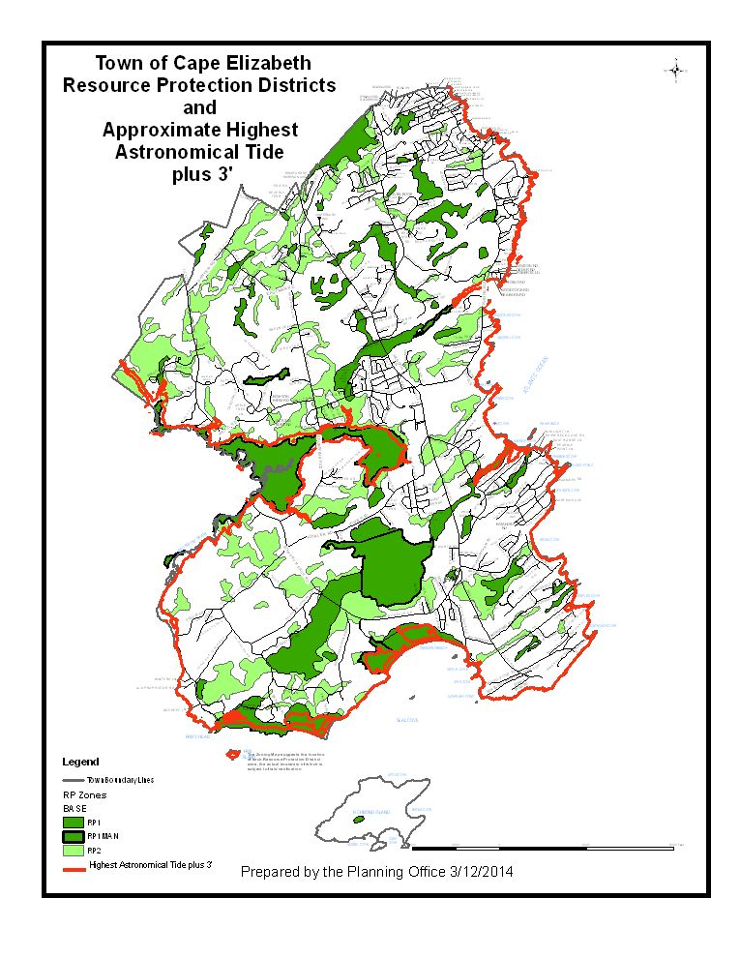

Planning Board Recommendation

At the March 18, 2014 meeting, the Planning Board approved the following motion by a vote of 6-0.

BE IT ORDERED that, based on the materials reviewed and the facts presented, the Planning Board recommends the Normal High Water Line Zoning Amendments to the Town Council for consideration.

Note: All charts are from the presentation prepared by Peter Slovinsky, Senior Marine Geologist with the Maine Geological Survey, and shown at the October 29, 2013 Planning Board workshop. A copy of the entire presentation is posted on the town website under the 10-29-2013 Planning Board workshop supplemental
materials.

Zoning Ordinance

Normal High Water Line Zoning Amendments

SEC. 19-1-3. DEFINITIONS

Highest Astronomical Tide: The elevation of the highest predicted astronomical tide, referenced to Mean Lower Low Water (MLLW) at Portland Head Light tide prediction station. This prediction is based on an adjustment from the Portland tidal station. The highest astronomical tide is based on the most recent National Tidal Datum Epoch (NTDE) as determined from time to time by the National Ocean Service, an office within the U.S. Department of Commerce, National Oceanic and Atmospheric Administration.

Normal High Water Line : Adjacent to inland waters, the normal high water line shall be that line which is apparent from visible markings, changes in the character of soils due to prolonged action of the water or changes in vegetation, and which distinguishes between predominantly aquatic and predominantly terrestrial land. Areas contiguous with rivers and great ponds that support non-forested wetland vegetation and hydric soils and that are at the same or lower elevation as the water level of the river or great pond during the period of normal high-water are considered part of the river or great pond. Adjacent to tidal waters, the normal high water line shall be the topographic line located at the Highest Astronomical Tide, plus three (3) vertical feet upland.

SEC. 19-6-11. SHORELAND PERFORMANCE OVERLAY DISTRICT

A. Purpose

In order to maintain safe and healthful conditions; to prevent and control water pollution; to protect spawning grounds of fish, aquatic life, bird and other wildlife habitat; to protect archaeological and historic resources; to protect freshwater and coastal wetlands; to control building sites, placement of structures and land uses; to conserve shore cover; to protect visual, as well as actual, points of access to inland and coastal waters; to conserve natural beauty and open space; and to anticipate and respond to the impact of development in Shoreland areas, all land use activities within the Shoreland Performance Overlay District shall conform to the applicable land use standards in Sec. 19-8-2, Shoreland Performance Standards. This district is established in accordance with the provisions of 38 M.R.S.A. §435 et seq.

The Shoreland Performance Overlay District applies to all land within two hundred fifty (250) feet, horizontal distance, of the:
• normal high-water line of any great pond and the Spurwink River
• normal high water line of tidal waters; ;
• upland edge of a freshwater wetland

and all land areas within seventy-five (75) feet, horizontal distance, of the normal high-water line of a stream. This district also applies to any structure built on, over or abutting a dock, wharf or pier, or other structure extending, or located below the normal high-water line of a water body or within a wetland. (Effective October 15, 2009) The Town has prepared a zoning map showing the Shoreland Performance Overlay District based on the best available information at a town wide scale. The actual boundaries of this district, however, shall be determined from a field engineering determination of the topographic line as defined above.

